

Software Engineering Department
Ort Braude College
Course 61998: Capstone Project

Motion Recognition System for Surgery Assessment Using Deep Learning

Table of Contents
1. Introduction 3
2. BACKROUND 5
2.1.1 Kinect 5
2.1.2 CNN – Convolutional Neural Network 8
2.1.3 Convolutional Layer 8
2.1.4 Pooling Layer 9
2.1.5 Fully-Connected Layer 10
2.1.6 Activation functions + Softmax function 10
2.1.7 Backpropagation 10
2.1.8 Transfer learning 11
3. Expected Achievements 12
4. RELATED WORK 13
5. Research process 18
5.1.1 ResNet 18
5.1.2 Inception v-4 19
5.2 Process 20
5.2 Product: 22
5.2.1 Use-Case Diagram: 22
5.2.2 Class Diagram: 22
5.2.3 Gui 23
6. Testing plan 24
References 25

Abstract. Gait evolution is a key factor in moving towards a better surgical approach in the healthcare system regarding hip replacement surgery (HRS), using deep learning methods to evaluate a patient gait can bring tremendous benefits especially while using low-cost Mocaps devices. In our project we will use Convolutional Neural Network (CNN) for building an automatic system that will generate a skeleton model of a patient by recoding visual data based on his gait, the output of our system will be used for generating a report. The report includes parameters for the assessment of gait. The training of the system will be with the help of about 120,000 images from Bergamo hospital in Italy. There are some architectures that implement CNN, we will compare between two of them: ResNet and Inception v-4. Eventually we will choose one of the architectures for our system, in addition to those architectures we will examine the influences of Transfer Learning from ImageNet and the effect it has on the classification of joint.
- Introduction
Degenerative osteoarthritis of the hip joint (coxarthrosis) is the most common disease of the hip joint in adults. Although research has advanced knowledge of osteoarthritis, none of the known therapies can halt its progression. The elective procedure in the treatment of the hip osteoarthritis is universally recognized to be the prosthetic hip replacement surgery (HRS) known also as Total Hip Arthroplasty (THA). There are three methods to perform the surgery, some methods are more intrusive and dangerous, other methods require incredible precision from the surgeons, Or a slower recovery rate. [14]
There are many reasons why moving towards better surgical approach is a key factor for healthcare systems and surgeons. Besides straight economic motivations, the main goal is to provide patients with safer, more effective and quicker path towards the best healing condition. Therefore, many researchers conduct studies whose aim is to compare and rank the different surgical approaches available to THA procedure. [14]
Nowadays, healthcare institutions are not familiar with quantitative approaches for patients’ gait evaluation. As of now there aren't any defined methods for comparing post and pre-operative conditions of the patient. Using clinical information and the representation of the efficiency of functional recovery, in the short-term period before and after the surgical intervention. [14]
Previous solutions for motion capture and gait analysis exist and are reported in literature. These setups are highly performing but they are extremely costly, most of the times the systems are not portable and the use of markers on the body may introduce positioning errors. In addition, a wearable sensor is placed on a body part to capture the movement information. From only the body part where the device is worn, limiting the applicability across different use-cases. [14]
The aim of the present work is to evaluate if patients’ gait analysis based on low-cost portable marker-less Mocap and ad-hoc data elaboration is suitable to be used together with clinical evaluation methods for short run assessment. In addition using a computer vision based system to offer a reliable solution which may enhance patient comfort, particularly for prolonged monitoring periods. [14]
Our project in collaboration with Bergamo Hospital is designed to help people who have had Hip surgery, in fact to use advanced technologies such as marker-less MOCAP system in order to be able to give appropriate treatment to people. The system will be used for rehabilitation centers for physicians to apply proper care to patients according to the gait analysis our software provides. Deep learning is used as a learning methodology for achieving novel accuracy.
The project aims to provide gait evaluations by creating a human motion tracking system for medical analysis, which will create a benchmark for potential clinical and home applications. The objective is to create a software that can automate the process of gait evaluations. Our solution will deal with the captured data, gait recognition, allowing motion tracking and data processing to create a report. The input to the system will be provided from Motion capture device, referred to as MOCAP, which is the process of recording the movement of people and using that information to animate digital character models in 3D. Using two Kinects as Mocap devices for capturing the gait, the patient is asked to walk on a straight path marked on the floor without wearing bulky cloths. A normal RGB video and depth data are acquired simultaneously at 30 fps (Figure 1). Finally, this data is composed to a skeleton model.
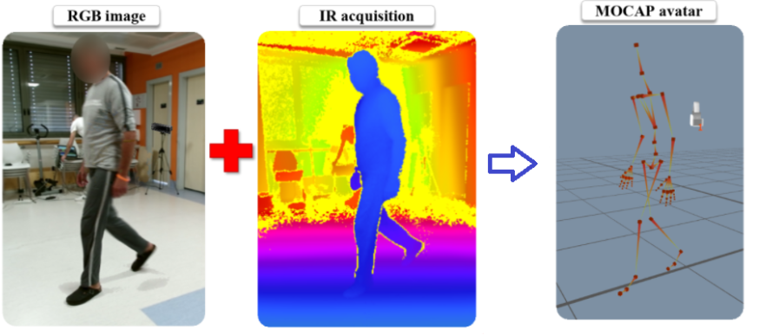
The system will be easy to use by medical personal and will not require a computer specialist to use proficiently. Furthermore, the system can be adopted on a large scale use, not only for THA procedure but also any other procedure that may include the use of gait analysis.
The main challenge of our project is tracking motions and to classify joints from the video data. To provide suitable and accurate evolution of the patient gait in an automated process. in our work we use information derived from a trained Convolutional Neural Network (CNN) model in order to estimate the skeleton model. Using the Kinect camera, a skeleton model can be extracted in a compact representation of major points in the body such as head, shoulders, elbows, hands, hips, knees or feet [15]. These major points are referred to as joints. Even though the Kinect has a built-in solution for skeleton model estimation, it has found only a limited use for patient monitoring applications in a clinical scenario. Kinect’s skeleton model estimation has been trained for gaming applications and fails to work in clinical scenarios [13]. Even though deep learning methodologies in particular with the CNN have proved themselves in similar tasks of human motion recognition and classification especially for the entertainment industry. In the medical field human motion recognition must be performed on a high-level accuracy to prevent further medical complications and to properly assess the situation of the patient. Not allowing any errors or miscalculations.

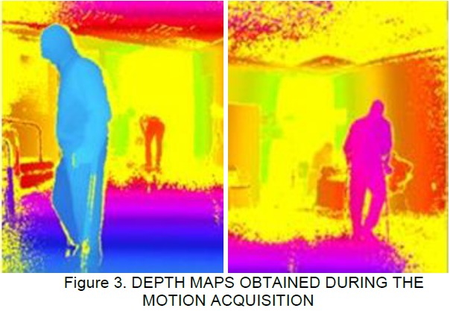

Figure 1. Depth maps obtained during the motion acquisition. [14]

The paper is organized as follows.
In Sect. 2, we describe the background and related work.
In Sect. 3, we describe the expected achievements.
in Sect. 4. Finally, the Research/Engineering process
in Sect. 5. We describe the Evaluation/Verification Plan

- Background

Kinect
Kinect was built to revolutionize the way people play games and how they experience entertainment. With Kinect, people are able to interact with the games with their body in a natural way. The key enabling technology is human body language understanding. The computer must first understand what a user is doing before it can respond. This has always been an active research field in computer vision, but it has proven formidably difficult with video cameras. The Kinect sensor lets the computer directly sense the third dimension (depth) of the players and the environment, making the task much easier. The sensor incorporates several advanced sensing hardware. Most notably, it contains a depth sensor, a color camera, and a
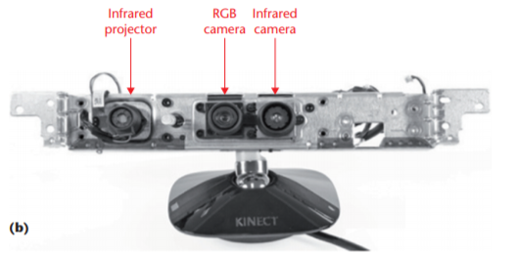
four-microphone array that provide full-body 3D motion capture, facial recognition, and voice recognition capabilities.
Figure b shows the arrangement of the infrared (IR) projector, the color camera, and the IR camera. The depth sensor consists of the IR projector combined with the IR camera, which is a monochrome complementary metaloxide semiconductor (CMOS) sensor. [17]
Fig b.

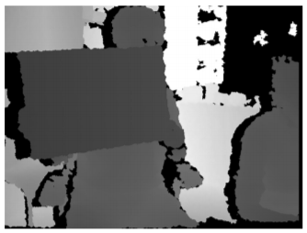
Using the IR (infrared) camera sees dots in the image The relative geometry between the IR projector and the IR camera as well as the projected IR dot pattern are known. If we can match a dot observed in an image with a dot in the projector pattern, we can reconstruct it in 3D using triangulation. Figure c shows the depth map produced by the Kinect sensor for the IR image. The depth value is encoded with gray values. The darker a pixel, the closer the point is to the camera in space. The black pixels indicate that no depth values are available for those pixels. This might happen if the points are too far being too close, are in the cast shadow of the projector or reflect poor IR lights. [17]
Fig c. Kinect sensor depth image, the sensor produces this depth image from the infrared dot image

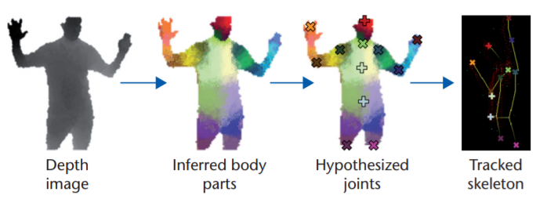
For our project we focus on the Kinect Skeletal Tracking: in skeletal tracking, a human body is represented by a number of joints representing body parts such as head, neck, shoulders, and arms. Each joint is represented by its 3D coordinates. The goal is to determine all the 3D parameters of these joints in real time to allow fluent interactivity and with limited computation resources. For that to work properly there is a need to evaluating each pixel separately to avoid a combinatorial search over the different body joints. For training data, there is a need to generate realistic synthetic depth images of humans of many shapes and sizes in highly varied poses sampled from a large motion-capture database. Microsoft team train a deep randomized decision forest classifier, which avoids overfitting by using hundreds of thousands of training images. Simple, discriminative depth comparison image features yield 3D translation invariance while maintaining high computational efficiency. For further speedup, the classifier can be run in parallel on each pixel on a graphics processing unit (GPU). Finally, spatial modes of the inferred per-pixel distributions are computed using mean shift resulting in the 3D joint proposals. Figure d illustrates the whole pipeline of Kinect skeletal tracking. The first step is to perform per-pixel, body-part classification. The second step is to hypothesize the body joints by finding a global centroid of probability mass through mean shift. The final stage is to map hypothesized joints to the skeletal joints and fit a skeleton by considering both temporal continuity and prior knowledge from skeletal train data. [17]
Fig d. The Kinect skeletal tracking pipeline

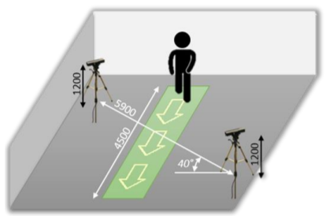
According to University of Bergamo Their method adopted to acquire the way patients walk before and after the THA surgery is derived from an ad-hoc roadmap. This roadmap has been conceived to analyze generic human motion with low-cost Mocap technologies. The approach has been designed so that it can be applied in different contexts and with different purposes. The first part is related to the acquisition of the motion, a second part is related to knowledge management. The motion sensors adopted for the method are two Microsoft Kinect version 2, exploiting the time-of-flight principle for measuring the depth in addition to RGB data captured at 30 frames per 3 second (fps). The sensors are placed opposite to each other at about 6 meters of distance and diagonally respect to the walking path as shown in Figure e. This configuration is robust, broadly used and it guarantees a walking length of more than 4 meters, which is enough for acquiring at least two complete step cycles. The flexibility, portability and ease of use make the Kinect v.2 sensors the best choice available. The major but not critical limitation is due to the performance of sensors, in terms of resolution and frequency of acquisition. This does not affect the assessment process for this kind of application in which the person moves relatively slow. [14]
Fig e. Motion capture system configuration

The software solution used for capturing Kinects data is provided by iPisoft and it allows recording, tracking and analyzing 3D motion data. A cloud database is set up to conveniently organize and store raw data obtained with the acquisition sessions. iPiSoft manages the initial data (i.e., RGB videos, point clouds) in order to make available to the user a set of tools to generate the avatar in a simplified way, but it is not performed in an automatic way. The user must use iPiSoft to obtain the final avatar (i.e., the bvh file) ready to be used for a further context (i.e., medical assessments in our case).
Kinect output:
The video frames stream is given as 4 bytes per pixel in BGRA format (blue-green-red-alpha) and the pixels are scanned line by line horizontally in the image domain. for example, a full uncompressed frame of size 640x480 has 640x480x4 bytes. The depth frames stream is given as 2 bytes per depth pixel in unsigned short format. The value of the unsigned shorts represents the distance from the camera plane in millimeters, ignoring the 4 least significant bits. The 4 least significant bits contain the identity of the player at that particular pixel. for example, a full uncompressed frame of size 320x240 has 320x240x2 bytes. Each joint has 11 properties: color (x, y); depth (x, y); camera (x, y, z) and orientation (x, y, z, w).
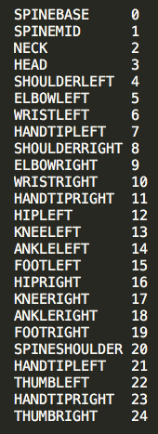
Each joint has 11 properties: color (x, y); depth (x, y); camera (x, y, z); and orientation (x, y, z, w).
The Kinect has two cameras—a color (RGB) camera and a depth camera—and they have different resolutions. The color camera is 1920 x 1080. The depth camera is 512 x 424. The color coordinates (x, y) are the coordinates of the joint on the image from the color camera. The depth coordinates (x, y) are the coordinates of the joint on the image from the depth camera. row/column location of a pixel where x is the column and y is the row. row/column location of a pixel where x is the column and y is the row.
Camera space refers to the 3D coordinate system used by Kinect. The coordinate system is defined as follows:
The origin (x=0, y=0, z=0) is located at the center of the IR sensor on Kinect
X grows to the sensor’s left [from the sensor’s POV]
Y grows up (note that this direction is based on the sensor’s tilt)
Z grows out in the direction the sensor is facing
1 unit = 1 meter.

CNN – Convolutional Neural Network
Convolutional Neural Network (CNN) is class of deep neural network commonly used for classification, regression localization and segmentation. CNN has become dominant in various computer vision tasks such as image classification and object detection. Currently it’s the most popular network model used for image classification. The main idea of CNN is that with local understanding through local optimization of an image is sufficient enough. CNN has multiple layers regardless of the type of architecture used and these layers include:
Convolutional Layer, Pooling layer, Fully connected layer as we can see in Fig.3.
The input of the first layer is an image, each layer in the CNN is composed of several neurons that have learnable weights and biases. The convolution operation takes local features of the image by dividing it to small parts and that’s how it learns its features. With CNN there is less parameters which makes the learning time period significantly lower for training the model. In the training process, CNN used the backpropagation algorithm which regulates the weight change in relation to the input to learn more and more. The output is a vector that represents the probability of being connected to a specific class. [1]

Convolutional Layer
A Convolutional layer is a key component in CNN. Convolutional layers do not connect to every neuron in the previous layer but connect to groups of neurons. This allows a convolutional layer to detect patterns or features within a group of neurons which the next layer can extrapolate on. This works well for image processing because real world images typically follow this pattern. The parameters for the layer consist of learnable filters, the filter is small compared to the input but they extend to the full depth of the input and each one is convolved a crossed the full input volume. The end product is a 2-dimensional activation map that present the answer that the filter let us on the input. CNN stacks these maps and produces a volume of filters accordingly also the CNN learn filters that activate when they see some type of familiar features. Each filter is looking for different things in the input but some can work on a similar area. Stacking the activation maps for all of filters along the depth dimensions forms the output of the convolution layer. Each entry in the output can be interpreted as an output of a neuron that looks at a small region in the input and shares parameters with neurons in that activation map. [1]

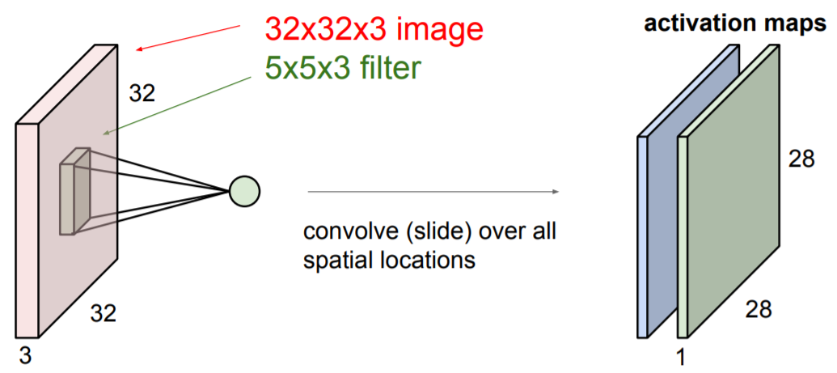
Fig: Convolution Layer with 3 5x5 filters,
we’ll get 2 separate activation maps. ‎[1]

Pooling Layer
Pooling layer is a common practice in CNN architecture, placed between successive convolution layers. The pooling layer operates upon each feature map separately to create a new set of the same number of pooled feature maps. Pooling involves selecting a pooling operation, much like a filter to be applied to feature maps. The size of the pooling operation or filter is smaller than the size of the feature map, specifically it is almost always 2×2 pixels applied with a stride of 2 pixels. This means that the pooling layer will always reduce the size of each feature map by a factor of 2. The pooling operation is specified, rather than learned. Two common functions used in the pooling operation are:
Average Pooling: Calculate the average value for each patch on the feature map.
Maximum Pooling: Calculate the maximum value for each patch of the feature map. The main responsibility of the pooling layer is to make the representation smaller and more manageable. [2]
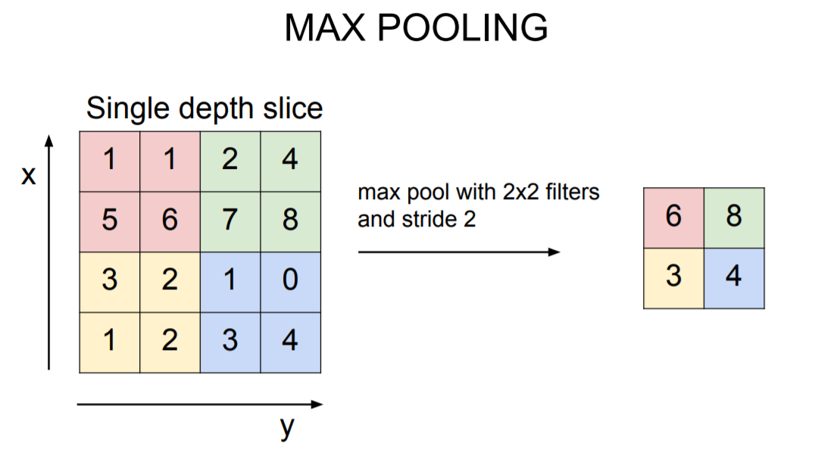
Fig.2: Example of max
Pooling. [1]

Fully-Connected Layer
Fully connected layer is called the output layer and it is located at the end of the network, as shown in Fig.3 it represents the class scores, meaning it represents the chance to be in each class. This layer takes an input volume and outputs an N dimensional vector where N is the number of classes that the program has to choose from. Each number in this N dimensional vector represents the probability of a certain class. The way this fully connected layer works is that it looks at the output of the previous layer and determines which features most correlate to a particular class. Basically, it takes the results of the previous layers in the CNN and classify their output into a label. The output of this layer is a vector that consist of probabilities that a feature belongs to a label. [3]
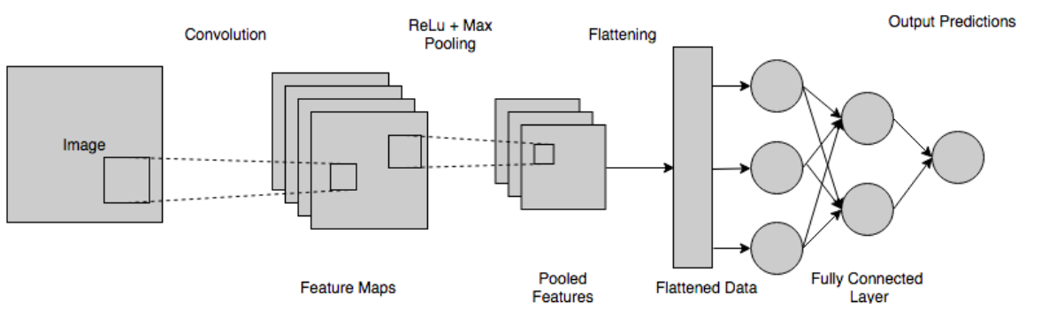
Fig. 3: CNN with a fully connected layer.

Activation functions + Softmax function
Activation functions are a crucial part of the neural network. It allows neural networks to create nonlinear/linear functions to solve a variety of problems. It transforms input values into acceptable range. The activation functions allow or don’t for neurons from firing into the next layer by comparing it into an activation function threshold. Out of the many activation functions RelU is most commonly used. RelU is linear for all of the positive values, zero for all of the negative values. Thus our network wont map negative results, and it won't take negative values into considerations. [8]
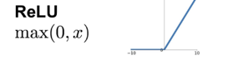
Fig. 4: ReLU function.

The Softmax function is frequently used as the final activation function in neural networks for classification problems, the function takes as input a vector of K real numbers and normalizes it into a probability distribution consisting of K probabilities. To each class in a multi-class problem. Those probabilities must add up to 1, because of this constraint it helps training coverage more quickly than it would without it [4]. Standard Softmax function is as follows in the equation:
$$σ{\left(z\right)}_{i}=\frac{e^{z_{i}}}{\sum_{j=1}^{k}{e^{z_{j}}}} for i=1,…,K and z=\left(z_{1},…,z_{K}\right)∈R^{K}$$

Backpropagation
Backpropagation is an algorithm commonly used to train neural networks.
When the neural network is initialized, weights are set for its input data, called neurons. Inputs are loaded, they are passed through the network of neurons convolution layers-feedforward pass, and the network provides an output for each one, given the initial weights. Backpropagation helps to adjust the weights of the neurons, the algorithm repeatedly adjusts the weights of the connections in the network to minimize the loss at every pass. Backpropagation computes the gradient of the loss function and can train the network using the gradient descent calculation [8]

Transfer learning

Transfer learning is a technique to improve the performance of a learning algorithm by using knowledge that is obtained from similar solved problem. The knowledge is transferred by obtaining parameters of the target model from related source model. According to [6] initializing a network with weights from a different task can improve performance compared to using random weights for initialization of a net. It can help with learning what model to use, and is also used to avoid overfitting during training, when there is insufficient training data in target domain. There are two strategies while conducting transfer learning, feature extractor and finetuning. fine-tuning initializes parameters according to the source model parameters and retrains the last several conv blocks of the CNN. The goal is to adjust the mid- to high-level features to the target domain, since conv blocks in the beginning represent low-level features, and they might be similar for both source and target domains. Retraining process includes data from the target data set, which go through a forward propagation at each training epoch. At the backpropagation, parameters in some layer's skip calculation because these parameters fixed, and only parameters in unfixed layers are adjusted by the gradient descent algorithm. In feature extractor strategy convolution operations performed once in the feedforward procedure. features from the last layer are fed into a shallow fully connected layers, which are trained on the target dataset. Flowchart of transfer learning from [5] is depict in Fig 7. The effectiveness of transfer learning increases if the difference between the original task and the target task is smaller. In our case, the original task is human body pose estimation and the target task is
joints detection and skeleton generation, which are relatively similar. Therefore, in our project we decided to transfer parameters from the openPose network which refers to the task of human body pose estimation and used for training CMU Panoptic Studio dataset that contains 65 sequences (5.5 hours) and 1.5 millions of 3D skeletons. The openPose model is more relatable to our objective than ImageNet, our data is very different from the ImageNet dataset. OpenPose offers [16] sufficiently reliable 2D skeleton data to train a machine learning model, as well as being easy to use and very well documented also the model offers pertained datasets so the transfer learning technique can be adequately implemented.
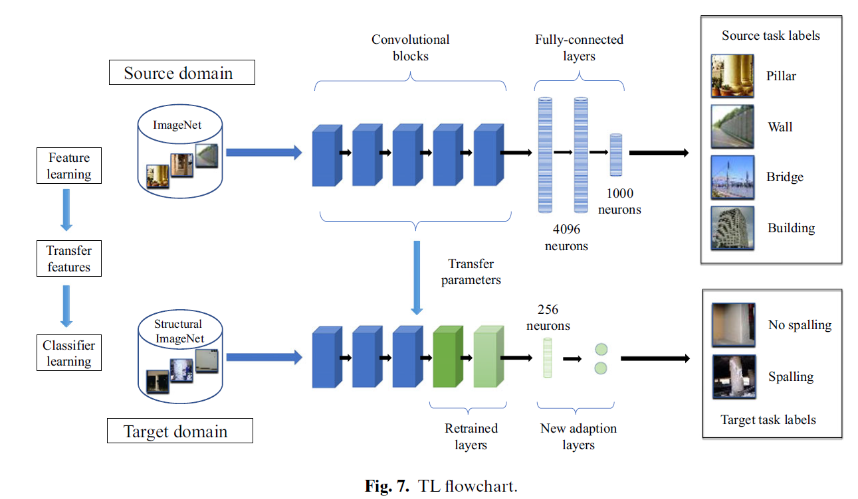
- Expected Achievements
The main objective of our project is to build an automated system that takes Kinect information and transforms it into the skeleton model using CNN and transferring the learned features from OpenPose pre-trained model to our system and by so minimizing the training process. The system will serve the rehabilitation hospital with conducting research on pre- and post-operative patients. Our expectations are to make our model as accurate as possible, so the hospital will get the most beneficial report.

Expected project goals:
1. We expect to build a reliable and accurate CNN, therefor we learn the appropriate unique HyperParameters for our system in order to obtain the lowest possible loss in the training phase.
2. Our system will serve the rehabilitation hospitals. The system will help researchers with the study on post and pre-operative patients. The system will help doctors decide on which procedure to preform based on the data acquired from our system and thus can save lives and prevent medical malpractice.
3. A Big Data system which consumes a lot of information and provide large amounts of information compared to the low price of the system activation. The system will use recorded data from cheap and affordable MOCAPS like the Kinect which is comparatively cheap as opposed to the incredibly expensive equipment typically used in hospitals for medical examinations, increase the availability of this kind of tech in places without financial means, basically it’s a low-cost solution for hospitals who spend a lot of money for expensive systems for the same objective i.e. the CT scanner.

4. Related work
Laraba, S., Brahimi, M., Tilmanne, J., & Dutoit, T. [10], proposed the 3D skeleton-based action recognition method. New methods have been able to create high dimensional trajectories to train classification model that is able to predict classes of new sequences. Despite the success in the field it is still less successful then the image classification field. Mainly because of the advances in deep learning, there is a new method of representing motion sequences which projects them to the RGB domain. Mapping 3D coordination's of the human joints based on color and transform the action classifications into image classification. This was tested with image classification algorithms in addition to CNN, after the evaluation on 3D human action recognition data there is great potential.
The proposed method is 3D sequence to RGB image transformation:
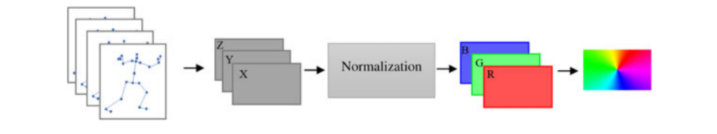
Sequence of body skeletons from a set of body joint locations in x-y-z view is created, Representation will be in a matrix form like so:
$$\begin{matrix}x_{1}\left(1(\right)y_{1}\left(1\right)z_{1}\left(1\right) & x_{1}\left(F\right)y_{1}\left(F\right)z_{1}\left(F\right) \\ x_{N}\left(1\right)y_{N}\left(1\right)z_{N}\left(1\right) & x_{N}\left(F\right)y_{N}\left(F\right)z_{N}\left(F\right)\end{matrix}-→F→frames ,N→body joints$$
Then the normalization process, mapping the values of the matrix into the RGB Domain (0-255 range) by extracting X, Y, Z matrix from the main matrix. Afterwards Computing formal matrix's to new R, G, B matrix's respectively to X, Y, Z. The process is to Compute red, green, blue values after normalization. $R\left(i\right)=255* \frac{x_{i\left(f\right)-min⁡(X)}}{\min\left(X\right)-max⁡(X)}$
Lastley combination of separate matrix's to a single RGB image,where each separate matrix represents a channel. The following method was tested on several datasets that are composed of everyday human Actions in addition to some sport's action: MSR Action 3D, HDM05, NTU RGB+D. Also, the method was tested on several classification algorithms (KNN, CNN, RF). Raw 256*256 images were used to train the classifiers.
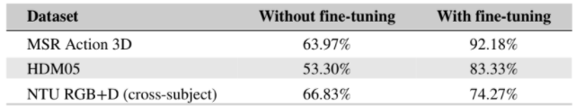
The results on all the datasets and algorithms has shown the method efficiency even without extracting complex feature that may cause problems for the classifiers. Also, the method was proven effective on different mocap system from expensive to cheap range meaning it is quality of data independent which is very good.

Ghorbel, E., Papadopoulos, K., Baptista, R., Pathak, H., Demisse, G., Aouada, D., & Ottersten, B. [11] Proposed using framework for RGB-based view-invariant action recognition. Due to the lack of 3D information in RGB images, using a single RGB camera to do view-invariant action recognition is quite challenging. In recent years the advances in deep learning made it less so. Using a framework with two key steps can be applied to do so efficiently:
1.An estimation of a 3D skeleton from an RPG camera using a CNN – based pose estimator.
2.Computing view-invariant skeleton-based features based on 3D skeletons.
he framework: Firstly, we need to generate 3D human skeletons from a monocular RGB camera according to the CNN based approaches. Figure 1 illustrates the pipeline.

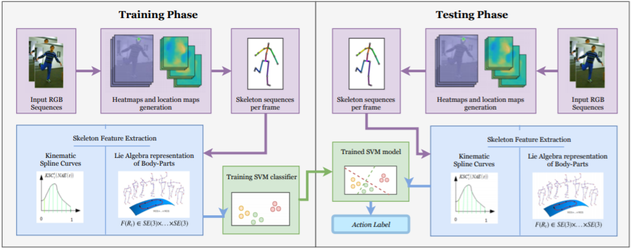
In both phases skeletons are extracted from RGB images using VNect algorithm then skeleton based features are computed, for the model we use linear SVM. Now the details of all the steps in the pipeline, Pose estimation from a monocular RGB image: Sequence of RGB images $R=\{R_{1},…,R_{N}-→N→frames$ is created. The main goal is to extract a 3D skeleton composed of n joints. mapping using an algorithm a single RGB-image to representation of a human pose in 3 dimensions. The goal is to make for each joint an estimation of a heat-map using a CNN network of body parts and their locations in all dimensions. According to the generated skeletons we can integrate two different view-invariant skeleton-based methods:
LARP: based on describing the geometric relationship between different coupled body segments. Each body part we get from a sequence of skeletons with n joints is assigned a 3D local coordinate system, between each couple of local coordinate systems of body-parts a 3D rigid transformation matrix is defined and later estimated that ensures view-invariance.
KSC: defines a kinematic curve of a skeleton sequence, the curve can be reparametrized so it's invariant to execution rate using method called TVR. Using Motion Signal Energy function defined the last needed parameters. Finally, the classification is carried out using a linear SVM. The framework was tested on different cross-view human action recognition benchmarks, results from accuracy on the Northwestern-UCLA dataset:
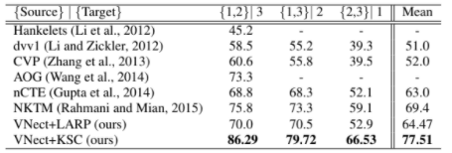
Results from the first dataset prove that this method outperforms state-of-the-art methods, by around 8% compare to the most competitive approach NKTM. Results from the second dataset (IXMAS) show that this method achieves 58.12% recognition accuracy However for almost every viewpoint pair this method shows competitive performance. The main advantage of the framework is its low commutation time which shows that this framework can be considers a real-time system.

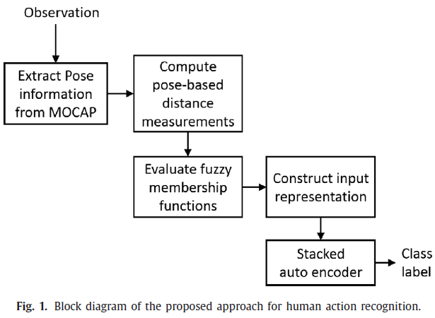
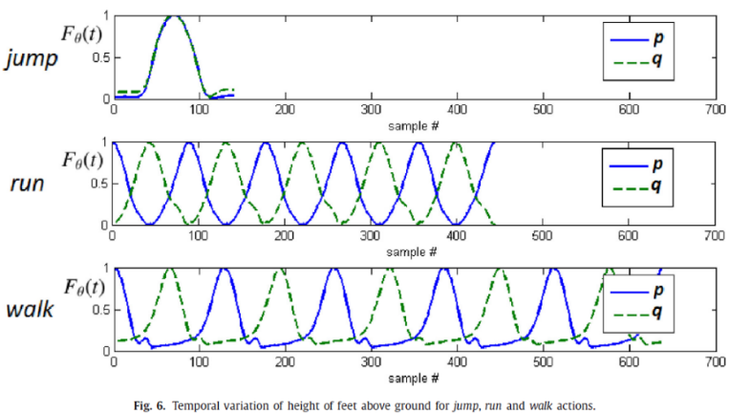
Earnest Paul Ijjina and Krishna Mohan C [12], proposes a method to identify and classify human actions. They claim that statistical information of key movements of actions can be leveraged in designing an efficient input representation, using fuzzy membership functions for Stacked Auto Encoder (referred to as SAE) system which learns pose-based features of those human actions and categorize them. Block diagram is shown in Fig1. MOCAP is used to extract the temporal variation of the subject’s pose during the execution of the action. MOCAP information contains the tracking information of human-joints over time. This information is used to compute pose-based distances from small number of skeletal joints. These distances are evaluated by a set of fuzzy membership functions, that are designed to emphasize the unique motion pattern of each action. The membership values from these functions are concatenated to generate the input representation of the action. Architecture of SAE consists of three layers for action recognition. The model evaluated on CMU MOCAP dataset that consists of locomotion actions such as jumping, walking and running. In Input representation they use the domain knowledge for locomotion actions, which involves periodic movement of feet and the actions only differ in the duration and relative (simultaneous or alternative) motion of the feet. In Fig 6 this point is illustrated where p is the distance between the right-leg and the ground and q is the distance between the left-leg and ground. The membership values are appended to generate the input representation. The periodic nature of these locomotion actions can be used in the design of a one-shot training model in which a single observation per class is used to train the model. The model gains recognition accuracy of 97.47%, while the experiments of the proposed action representation using CNN classifier performance is 94.44%. Also, this model evaluated on Berkeley MHAD dataset which consists of MOCAP information of the actions: jump, jumping jack, bending, punching, wave 2 hands, wave 1 hand, clapping, throwing, sit and stand, sit down, stand up. In order to create an input representation for the SAE, 3 joints are used for the computation of the distances. these distances are normalized using the reference pose (T-pose) of the subject. The movements involved in these actions are statistically analyzed by plotting the range of minimum and maximum values of these distance variables for the 11 MHAD actions. The variation range of these variables is not identical for these actions. This analysis is utilized in the design of six membership functions. The core function gets executed only when there is a significant change in the value of the variable. An average classification accuracy of 98.03% is obtained using the proposed approach performance which is better than many approaches even when MOCAP information of only 3 joints is considered in input representation. Even though the performance of proposed approach using CNN classifier is close to SAE, the SAE classifier is preferred because its performance is less sensitive to the initial weights (due to its layer-wise pre-training), when compared to a CNN classifier.

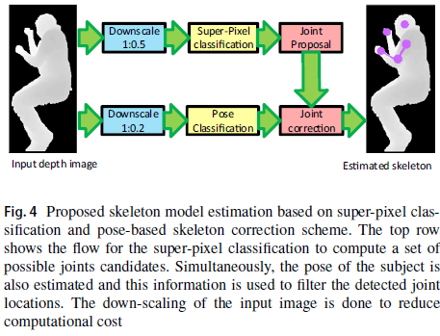
Zavala-Mondragon, L.A., Lamichhane, B., Zhang, L. and Haan, G.D. [13], Propose a skeleton model estimation method for patient sleeping monitoring in a general clinical setting and focuses on the upper body only. This approach makes use of trained CNN that extracts movement information from posed skeleton depth images (referred to as CNN-SkelPose). The dataset used in this research is made of videos recorded in a room setting and contained subject alternates between different poses and moves in different patterns. The algorithm consists of the components described in Fig4.
First of all, procedure used for the segmentation of the subject from the background is done as pre-processing data for all image frames in the video. CNN-SkelPose identifies the possible joint locations based on the classification of each super-pixel. A super-pixel can be defined as a group of pixels that share common characteristics. Those super-pixels are recognized by a CNN, which is trained with patches extracted from a training dataset video (Fig 6).
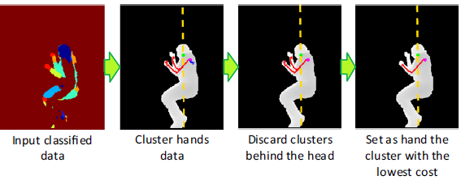
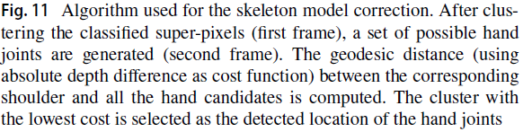
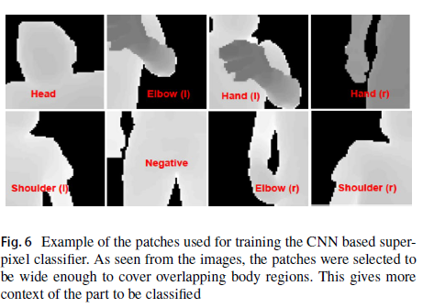
The CNN Architecture consist of input layer, two stacked layers of Convolution-MaxPooling-Activation followed by a fully connected layer. and a final output layer. After super-pixel classification, a set of joint proposals are generated by clustering each predicted class. Clustering the proposed joint locations is used in a mean-shift algorithm which uses an image coordinate domain. There are multiple joint clusters for a joint type and only after the pose detection component the correct cluster is filtered. The model includes identifying patient’s pose in order to obtain a reliable skeleton model and decrease fuzziness in left and right body joints which can occur if the patient is lying on the side of the body. The identified poses by the CNN are: lying on left/right side or supine. CNN architecture consists of input layer, three stacked layers of Convolution-MaxPooling-Activation followed by two fully connected layer. In the final output layer. Skeleton model correction is done according to the information of the detected pose. If the subject is lying on one side of the body, the algorithm discards the joints proposals of shoulder and elbow, which are opposite to the camera because it is unlikely that they are visible in the image. Afterwards, the cost to move from the detected shoulder joint to other suggested joints is computed by Dijkstra’s shortest-path algorithm, where the final hand joint is set as the candidate with the shortest path from the detected shoulder joint. The visible elbow joint is set as the center of the elbow candidate with the shortest Euclidean distance to the path connecting the joints of the shoulder and the hand. The hand that is opposite to the camera is set as the largest cluster at a higher depth value than that of the visible shoulder joint (Fig11). CNN-SkelPose results valuated compering the Skeltrack model. This approach gives better results compared to Skeltrack. When the subject is lying on one side of the body Skeltrack performs poorly while CNN-SkelPose provides good skeleton in comparison to the reference skeleton model, in this pose Skeltrack has an error of 50 cm in detection hand joint while in CNN-SkelPose the error is reduced by factor of 5. In lying on the right-side pose, the suggested model achieved a precision greater than 0.5 for all visible joints. In regards to the super-pixel component, for lying still subjects, the classifier formatting clear clusters where each joint is correctly isolated, in contrast to situations of motion subject where clear clusters are degraded especially for hand joints. Also observed, a confusion between left and right arm joints. The smallest errors, are present in the detection of the head and the shoulders joints. Higher stability of the estimated skeleton is obtained when the subject is supine. By comparing the results of the skeleton model estimated using CNN-SkelPose with and without pose, information can be deduced that leveraging pose information leads to increasing precision.

5. Research process
The project motivation is the understanding that the Healthcare sector is a high priority sector and people expect highest level of care and services regardless of cost. Most of the interpretations of medical data are being done by medical experts. In terms of image interpretation by human expert, it is quite limited due to its subjectivity, prone to human error, may have large variations across different experts, complexity of the video, and fatigue. After the success of deep learning in other real world application, it can also be applied in the medical field providing a good accuracy solution. Our goal is to gain a top level accuracy on our project, so our work can be used in rehabilitation centers around the world and the system will be a benchmark for potential clinical and home applications, to use deep learning techniques to automate evaluation process.
CNNs demand the definition of several training parameters that are not automatically adjusted during the learning process.

In this project we are going to explore the Hyperparameters which provide the most accurate results and a generalized classification model.

The Hyperparameters search consist of defining the Learning rate, Number of epochs, Batch size, Activation function, number of hidden layers and dropout.

In addition, we aim to examine how transfer learning may influence classification results. The main aspect under investigation is, if transfer learning done between similar tasks improve the results;

In this study, we utilized a supervised deep learning approach. Therefore, the structuring and labeling of the dataset is a fundamental step for performing the correct training and evaluation of the CNN.

The CNN Architectures researched include the following:

5.1.1 ResNet

Resnet is a CNN architecture that designed to solve the problem of training very deep networks by adding new layer of residual block (fig 5). This architecture supports hundreds of layers while there is a maximum threshold for depth with the traditional CNN model. meaning adding more layers can reduce performance. Residual block contains a “Skip Connection”, identity mapping, which increase performance in classification tasks compared to “plain” CNN architecture with the same number of layers. The identity mapping combines the output x of the previous layer, multiplied by a linear projection W, with the residual F(x) which is the output of the layer ahead (equation 1). The multiplication of identity and W is performed to expand the channels of shortcut to match the residual, that typically has smaller dimensions as a result of a convolution operation. An ensemble of deep residual networks achieved a 3.57% error rate on ImageNet which achieved 1st place in the ILSVRC 2015 classification competition. Also obtained a 28% relative improvement on the COCO object detection dataset. Deep residual nets achieved 1st place in ILSVRC & COCO 2015 competitions on the tasks of ImageNet detection, ImageNet localization, COCO detection, and segmentation. [7]
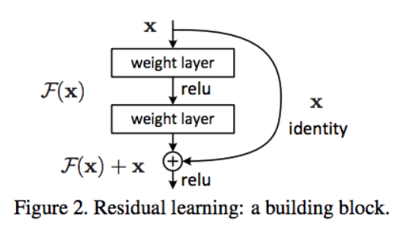
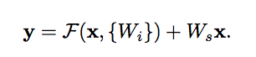
Equation 1

Fig. 5: Residual learning: a building block.

5.1.2 Inception v-4

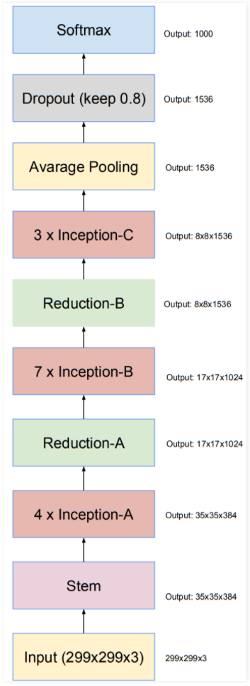
The Inception is a widely-used image recognition model that has shown to attain very high accuracy. The network essentially would get a bit wider rather than deeper, the inception module performs convolution on an input with different sizes(1x1,3x3,7x1,3x1) of convolutional layers. Additionally, pooling is also performed simultaneously, the outputs are concatenated and sent to the following inception module. Deep neural networks are computationally expensive to make it cheaper a limit to the input channel was made by adding an extra 1x1 convolution layer after each inception block they are used as a dimension reduction module to reduce computation by reducing the computation bottleneck. Inception v-4 consists of 3 models (A, B, C) each module is has composed of different layers, module B and C is for high dimensional representation and both of them use asymmetric factorization while module A uses standard Factorization with these modules the number of parameters is reduced for the network and the likelihood of overfitting is decreased thus the network can go deeper. Full architecture shown in fig 6.
Other popular CNNs just stacked convolution layers deeper and deeper, hoping to get better performance. The Inception network on the other hand, is complex. The architecture is built of previous iteration of the inception family by simplifying the architecture and using more inception modules then the previous versions. It used a lot of tricks to push performance, in order to optimize training speed layer size was tuned carefully, to balance computation between various model sub-networks. There are 2 types of inception architecture:
Fig. 6: Overall Architecture. ‎[1]08D0C9EA79F9BACE118C8200AA004BA90B02000000080000000A00000047006F006F0067006C0065004E00650074000000
Pure inception architecture-first layers "stem of architecture" modified to make it more uniform, these layers are used before the Inception block also the model can be trained without partition of replicas, this way we use memory
optimization of back propagation to reduce memory requirement.
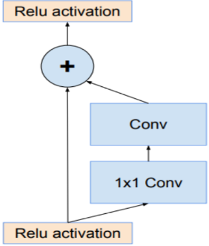
Inception architecture with residuals-due to the success of Residual Network a combination of the Inception with ResNets was formed. The inception blocks used in this architecture
Are computationally less expensive. Each Inception block is followed by a 1*1 convolution without activation. The pooling operation inside was replaced by residual connections in Inception ResNets models, batch normalization is not used after summations to reduce model size so it can be trainable on a single GPU. [9]
Optimization version of ResNets connections. ‎[1]08D0C9EA79F9BACE118C8200AA004BA90B02000000080000000A00000047006F006F0067006C0065004E00650074000000

5.2 Process
The system consists of training, validation and test parts.
For the training process of the CNN model, 120,000 images dataset will be used acquired by Bergamo hospital in the following process:
Two Kinect devices records 3600 frames for each acquisition. Each acquisition records both RGB video and depth data that generated as a video. The virtual avatar is generated during the acquisition represented as a file that contains the data for moving the virtual avatar.

In order to achieve successful training process with low loss we are going to examine the following Hyperparameters:
Learning rate – {0.000005, …, 0.0005}
Epochs – - {40, 50, …, 80}
Batch size – {8, 16, …, 64}

Concerning a relatively small dataset and short developing period we intend to apply transfer learning technique to overcome overfitting and to gain high performance in the system. Thus, we are going to use OpenPose SDK which conducts motion classification in real time scenarios of multiple people. openPose pipeline according to [18] is as follows:
The system takes as input a color image of a fixed size and produces the 2D locations of anatomical key points for the person in the image as we see in (e).
First a feedforward network predicts a set of 2D confidence maps of the body part locations (b) and a set of 2D vectors fields of part affinity fields, which encode the degree of association between parts (c). The set has N confidence maps, one per part and a vector per limb. Part pairs for taking into consideration as limbs, each image location encodes a 2D vector for then the confidence maps and the part affinity fields are parsed by greedy inference (d) to make the 2D key points output for every person in the image.
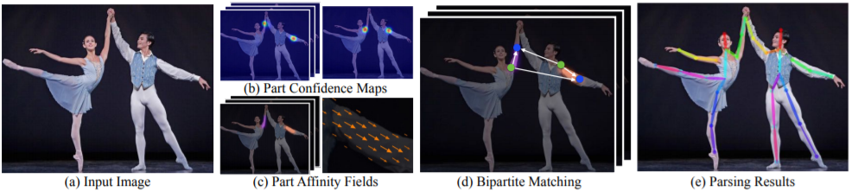
In order to extend our knowledge about the project we have learned the following:
1.Convolutional Neural Networks for Visual Recognition course from Stanford university.
2. The medical procedure Total Hip Arthroplasty (THA).
3. Deep learning concepts, specifically CNN, training process of CNN network, how to set hyper parameters and the effect they have on the system.
4.Different architectures that can be used for our project, Transfer learning technique.
5.Microsoft Kinect sensor and its capabilities and output, we have learned about different approaches to preprocess data before feeding it into the CNN network. 6.Super pixel recognition by CNN classifiers.

The learning process has gained us extensive knowledge about the aspects of CNN and its fundamentals, also we achieved understanding of deep learning architectures. This process contributed to the formulation of the background and related work for our project book, and we gained meaningful conclusions to the implementation of our project.

Our challenges:
The main challenge that we have encountered is learning the deep learning topic for the first time, and conduct an extensive research on the subject, it was achieved by taking a virtual course from an upscale university which was based on previous related courses which we didn’t participate in. Another challenge we faced is the learning process was theoretical and we couldn't practice on the technical aspects to gain deeper understanding of the topic. As well as the topic of deep learning being relatively new and constantly under development and the evaluation process is through trial and error, also there is no concrete explanation of the reasons that some hyperparameters values are superior than other values. Also, for the first time we were faced with academic articles which were challenging to comprehend.

5.2 Product:

5.2.1 Use-Case Diagram:
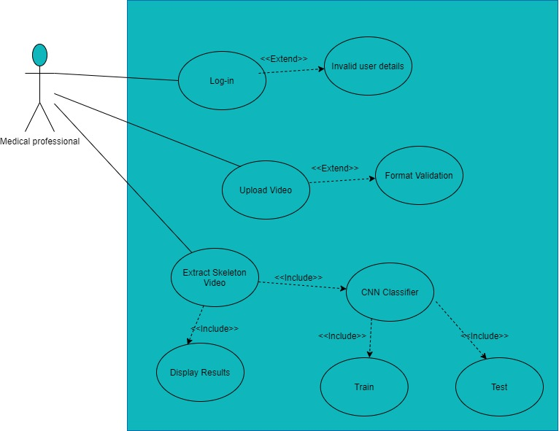

5.2.2 Class Diagram:
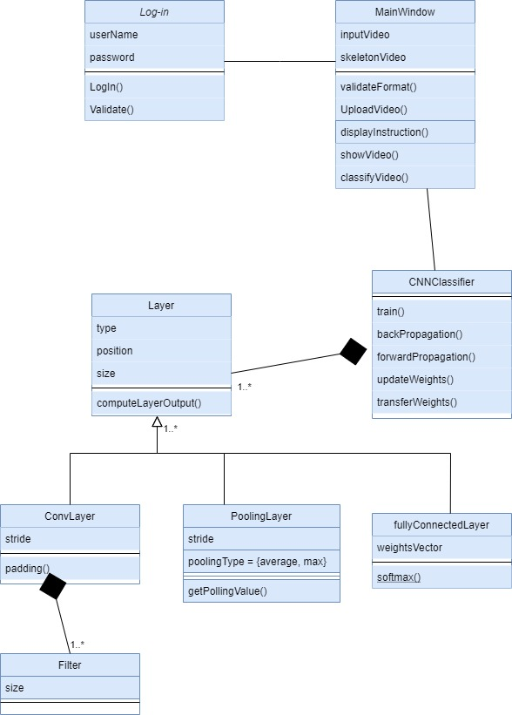

5.2.3 Gui
Start window:
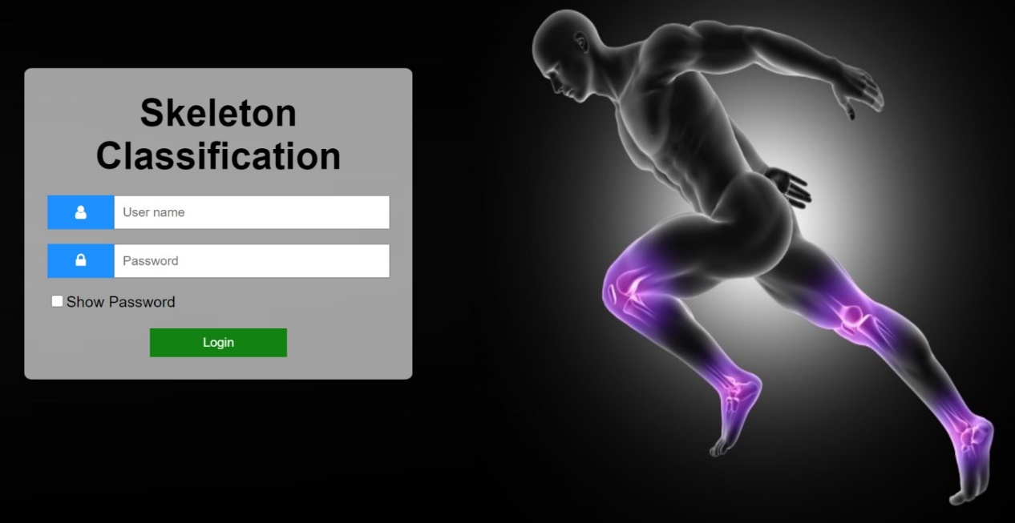

Main window and result window:
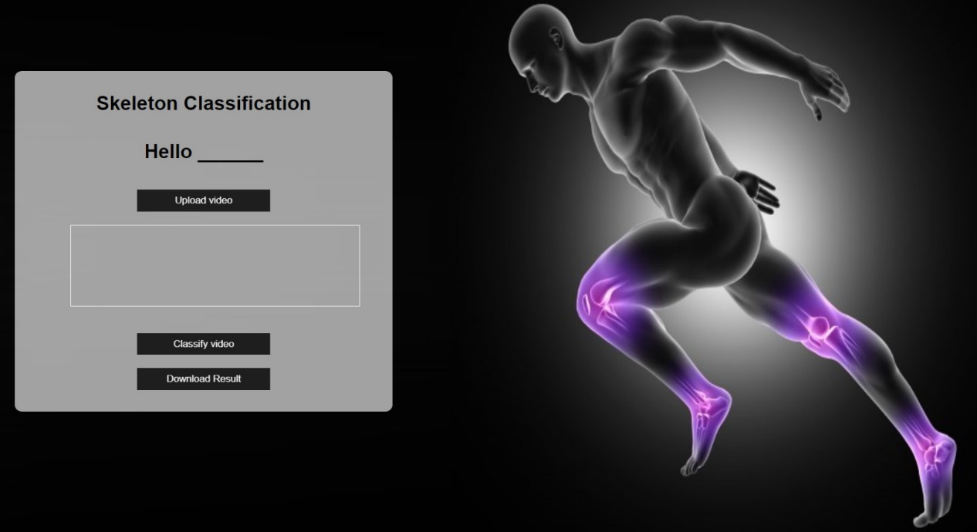

6. Testing plan
Case number | Test case | Expected result
1. | Try to train on an empty dataset | Popup Error – No dataset
2. | Try to login to system with valid user | The system will transfer user to main menu
3. | Try to login to system with invalid user | Popup Error – Wrong details
4. | Try to login to system with wrong information over 3 times | Popup Error – Access to system has been blocked for this computer please contact administration
5. | Insert Wrong video format | Popup Error – Wrong format
6. | Insert expected video format | The system will analyze the video
7. | Press 'Classify video' | The system will classify the video
8. | Press 'Download Result' | The system will give full result of the classification back to the user

References
[1] James Le, “The 4 Convolutional Neural Network Models That can classify your fashion
images”, Oct, 18
[2] A. Geron. Hands-On Machine Learning with Scikit-Learn & TensorFlow. O’Reilly Media, Inc., 2017.
[3] Adit Deshpande, &quot;A Beginner&#39;s Guide To Understanding Convolutional Neural
Networks&quot;, July 2016
[4] Zachary Singer, “Softmax and Uncertainty”, May 2019.
[5] Gao, Y. and Mosalam, K.M., 2018. Deep transfer learning for image‐based structural damage recognition. Computer‐Aided Civil and Infrastructure Engineering, 33(9), pp.748-768.

[6] Gattupalli, S., Ghaderi, A. and Athitsos, V., 2016, June. Evaluation of deep learning based pose estimation for sign language recognition. In Proceedings of the 9th ACM International Conference on PErvasive Technologies Related to Assistive Environments (pp. 1-7)..‏
[7] HE, Kaiming, et al. Deep residual learning for image recognition. In: Proceedings of the IEEE conference on computer vision and pattern recognition. 2016. p. 770-778.‏
[8] A. Khan, A. Sohail, U. Zahoora, A.S. Qureshi - “A Survey of the Recent Architectures of
Deep Convolutional Neural Networks”, 2018.
[9] Szegedy, C., Ioffe, S., Vanhoucke, V., & Alemi, A. (2016). Inception-v4, inception-resnet and the impact of residual connections on learning. arXiv preprint arXiv:1602.07261.
‏[10] ] Laraba, S., Brahimi, M., Tilmanne, J., & Dutoit, T. (2017). 3D skeleton‐based action recognition by representing motion capture sequences as 2D‐RGB images. Computer Animation and Virtual Worlds, 28(3-4), e1782.
[11] Ghorbel, E., Papadopoulos, K., Baptista, R., Pathak, H., Demisse, G., Aouada, D., & Ottersten, B. (2019). A view-invariant framework for fast skeleton-based action recognition using a single rgb camera. In 14th International Joint Conference on Computer Vision, Imaging and Computer Graphics Theory and Applications, Prague, 25-27 February 2018.
[12] Ijjina, E.P., 2016. Classification of human actions using pose-based features and stacked auto encoder. Pattern Recognition Letters, 83, pp.268-277.
[13] Zavala-Mondragon, L.A., Lamichhane, B., Zhang, L. and Haan, G.D., 2019. CNN-SkelPose: a CNN-based skeleton estimation algorithm for clinical applications. J Ambient Intell Humaniz Comput
[14] Regazzoni, D., Vitali, A., Colombo Zefinetti, F., & Rizzi, C. (2019, November). Gait Analysis in the Assessment of Patients Undergoing a Total Hip Replacement. In ASME International Mechanical Engineering Congress and Exposition (Vol. 83518, p. V014T14A003). American Society of Mechanical Engineers.‏
[15] Zhang, Z. (2012). Microsoft kinect sensor and its effect. IEEE multimedia, 19(2), 4-10.‏
[16] Aubry, S., Laraba, S., Tilmanne, J. and Dutoit, T., 2019. Action recognition based on 2D skeletons extracted from RGB videos. In MATEC Web of Conferences (Vol. 277, p. 02034). EDP Sciences.
[17] Zhang, Z. (2012). Microsoft kinect sensor and its effect. IEEE multimedia, 19(2), 4-10.‏
[18] Cao, Z., Simon, T., Wei, S.E. and Sheikh, Y., 2017. Realtime multi-person 2d pose estimation using part affinity fields. In Proceedings of the IEEE conference on computer vision and pattern recognition (pp. 7291-7299).

